**SYSTEM DESIGN:**

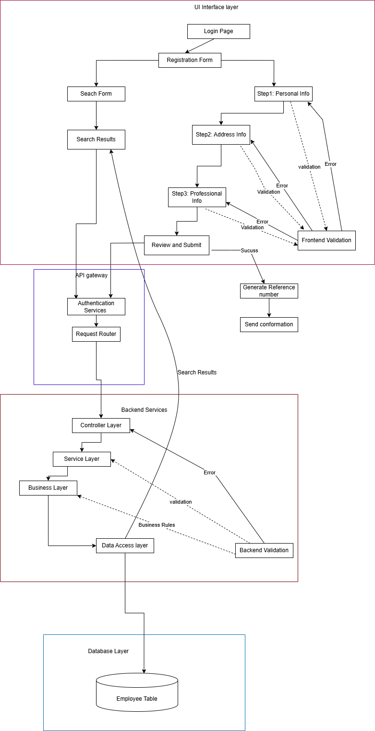

**Explanation about Search Page:**

In this system, a registration form is created to capture nominee details, such as name, age, gender, contact information, and relationship with the registrant. Upon submission, the backend (using Node.js) generates a unique registration number for the nominee, which is stored along with the nominee’s information in a MySQL database. This registration number serves as a unique identifier for each nominee. Later, users can search for the nominee’s details by entering the registration number in the search form. The backend queries the database using the provided registration number, retrieves the corresponding nominee’s information, and returns it to the frontend, where it is displayed for the user. This process ensures that each nominee is uniquely identifiable and their details can be easily retrieved using the registration number.